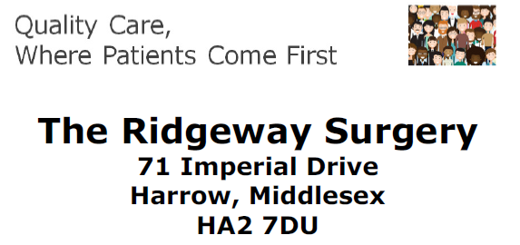
January 27th 2020
Dear Ridgeway Patients,
Please see the below letter from Dr David Lloyd to all our patients, letting you know that he will retire as a GP on March 31st 2020.
We know this will be a big change for our practice and we will very much miss the enormous contribution David has made as a doctor to our patients, as a colleague to GPs across Harrow and as an integral part of the Ridgeway and who we are.
We know that we cannot simply replace David but we are investing in expanding our team and bringing new clinicians on board to make sure that we can still provide high quality care. We are delighted to say that even though you may have heard in the media that recruitment is difficult in General Practice, we are very pleased to the response we have had to our search and we will be introducing new members of the team to you very soon
By enhancing our existing team and bringing in new GPs to join us, we will follow in the example set by practices elsewhere when facing longstanding GPs retiring.
We are aware that general practice is changing across the country with a greater emphasis on collaborating locally with other GP practices and healthcare providers.
We are confident that through the new members of our team who will join us and the development of our primary care network – a group of six other local practices we work closely with – we can continue to offer a responsive service to you.
We know that we have also trialled different ways of appointment access over the last 12 months and our overriding objective is to make sure we continually improve our appointments systems so we are there when you need us.
We continue to work closely with our patient group, the RSPG, to closely understand patient experience and feedback about our services and their ideas for how we can make our practice work in the best way for our diverse patient population.
We are certain that many of you will want to show your appreciation and thanks to David and we will be in touch shortly to let you know ways you can do it, should this be something you feel you wish to do. There are plans for an event to celebrate the fantastic care David has given to the local community and we will circulate this date when it is finalised.
David in conjunction with our clinical team is ensuring that all patients under his care are still able to have their specific healthcare needs met after his departure.
We will continue to keep our patients updated about our practice developments and will contact you soon with further information regarding the above,
Yours sincerely,
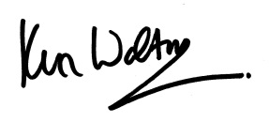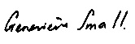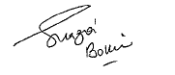
Dr Kenneth Walton, Dr Genevieve Small and Dr Shazia Bokhari.

January 27th 2020
Dear Ridgeway patients,

41 years ago, a new doctor arrived at the Ridgeway Surgery to serve his apprenticeship. For the next
3 years, he worked at Northwick Park Hospital and whenever he could, he helped the then single-handed GP, Dr Shackleton with his holiday locums.

On September 1st 1981, that same GP joined the practice as a partner and has never left. I was and
am that GP and now am planning to retire.

My last day in the practice will be on the 31st March 2020. This has been a very hard decision for me but a
combination of factors has made this happen. I will be 67 In March and my family has had its fair
share of problems last year. The job that I do at the Ridgeway has been a full time one and it is not
the sort of job that can be condensed into any less time.

General Practice is changing very fast and while old doctors like me prided themselves on being generalists, able to turn a hand to any problem that might turn up.

There is now so much to know that GPs as well as being generalists need to specialise in a few areas.

The future of patient care will be much more team based and that is the way the Ridgeway is aiming
to work 40 years is a long time and I know that there are many of you that have gone through your lives receiving your health advice from me. And for some of you, it may be a bit of wrench to think about seeing another doctor. Some of you may breathe a sigh of relief and be pleased to see someone with a fresh pair of eyes!

My partners will continue to run the practice and soon we will be able to share with you news of
other team members that are going to step in to replace me and carry on the work making the
Ridgeway the modern caring practice needed in this ever changing world.

I cannot say goodbye to you all one by one and so I hope you will forgive me writing this impersonal
letter. It has been a privilege serving you all these years.

Yours sincerely

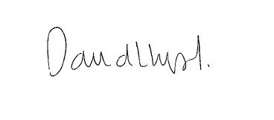

Dr David Lloyd

